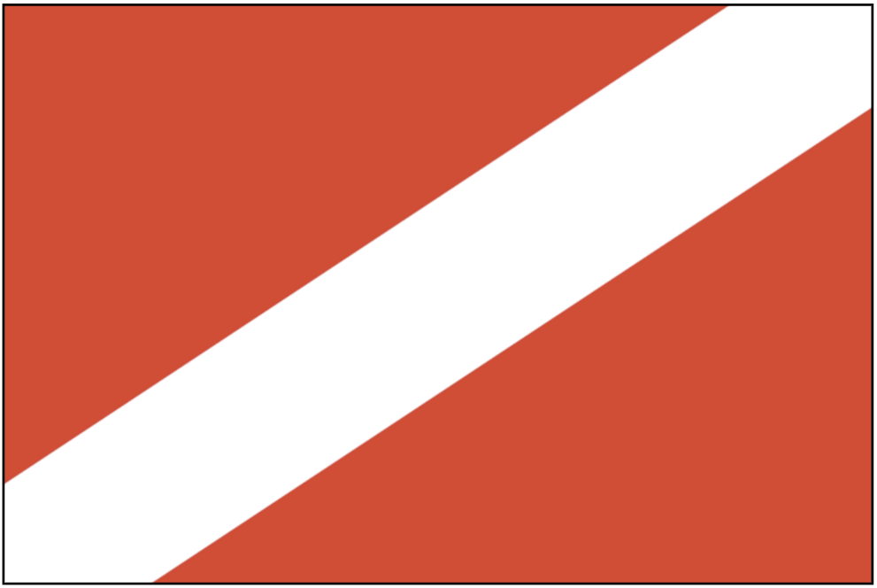


Population: 1542 Rosal citizens,100-200 Gliesese and Proximan
refugees

Starting Crew, Resources and Units:
5 Untrained Crew
3 Security Units
5 Food
1 Transport Shuttle

Rosal is the oldest of the New Nations, and you are proud to represent the values of self- determination and taking a stand against oppression and corruption. Before 'The Attack', Rosal was well-known as a power willing to stand up for what is right and speak out against oppressive voices in the Council.

The Shepherd is the fleet's main provider of essential food supplies, though you also have some of the best trained crew in the fleet, and may need to provide help to other vessels if they need it. In case it isn’t obvious, the food production of your ship is literally keeping the fleet alive, and other ships will be asking you for it constantly. You may be able to use this to ensure Rosal remains in a position of power.

As something of the de-facto leader of the New Nations (along with Proxima and Gliese) you feel a responsibility to act as a counter-balance to the entrenched powers of the Old Nations.. You fought hard against their colonial forces for decades, and your freedom was paid for in the blood of your ancestors. You were the first of the New Nations to gain your independence from the FAS and must continue to be a shining beacon for the oppressed, wherever they may be.

The FAS is an old enemy. Though your military conflicts ended long ago, they take every opportunity to undermine you politically, and are generally untrustworthy and oppressive. You are concerned that the President of the Council was born a resident of the FAS – though legally the President is bound to neutrality, you should be observant and ensure it doesn't sway their decision-making.

The CPA and SAN are easier to negotiate with, but as Old Nations they are still pompous and frequently need opposing when they try to sway the Council in the wrong direction. Do what you can to keep their tenuous coalition from developing into an unassailable political power bloc.

Proxima tends to put their foot in their mouth more often than not, but they don’t seem to be picky with who they insult so you consider them more of an irritation than an enemy. Their hearts are in the right place though, and as a fellow New Nation you share their independent spirit.

Gliese are old friends, often exhibiting a “New Nation” style rebellious spirit that you respect. You value being on good terms with them given their control of important resources.

Helvetii is an enigma and a recent addition to the Council. They seem to have the “New Nation spark” and are very open minded and consistent with their neutral political approach. They could prove to be a good negotiator and ally. This may also prove to be an issue if it comes down to the New Nations needing to take a stand, and their lack of commitment to an ideal makes them something of political cowards.

Objectives

• Ensure that Rosal is seen as an important and proactive nation. Do not be afraid to oppose other nations when they do wrong.

• Keep close connections with the other Rosal citizens aboard the Endeavour – they could be valuable allies.

• Stop the Old Nations (especially the FAS) from gaining political power. Rosal deserves to be in a position of leadership and you should be doing what you can to get there! While elections are technically far in the future, the current President lucked into their position by virtue of being the only survivor of the previous cabinet and there have already been discussions of holding new elections…

Council Member

The Council member for Rosal can spend the Team Phase (Phase 2) on either the Shepherd or the Endeavour, if they wish.

